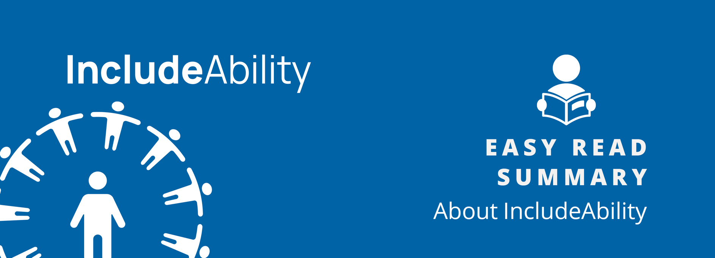
The Australian Human Rights Commission has a project called IncludeAbility.
The Disability Discrimination Commissioner, Dr Ben Gauntlett, is the leader of IncludeAbility.
IncludeAbility has been made to
- help people with disability get a good job
- help organisations create good jobs for people with disability.

What is IncludeAbility?
The IncludeAbility project has four parts.

The IncludeAbility Employer Network
This is a group of organisations who want to make good jobs for people with disability.

An Ambassador Advisory Group
This is a group of people with disability.
They give advice to the employer network organisations about the needs of people with disability.

The IncludeAbility website
This is a website that includes information for
- people with disability who want a good job
- organisations who employ people with a disability

Pilot Programs
The IncludeAbility team and network organisations will create some employment programs together.
These programs will look at new ways of creating good jobs for people with disability.
For more information visit
www.IncludeAbility.gov.au.

